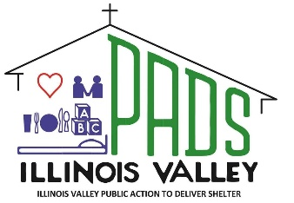
IV PADS Homeless Shelters Peru / Ottawa
P.O. Box 1012 LaSalle, IL 61301
815-224-3047 www.ivpads.com
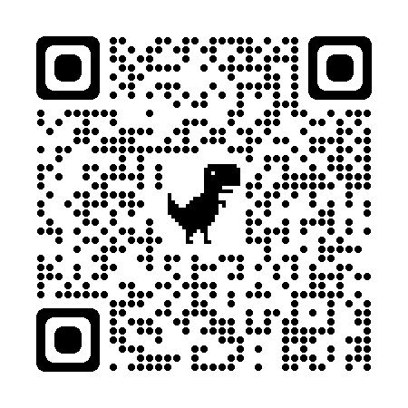
Scan to Donate
Help for Today…Hope for Tomorrow May 2025
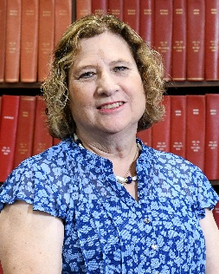
Update on New Shelter in Ottawa

In order to build the new shelter, the current building must be demolished, leaving us without a location.
Carol Alcorn,
Executive Director
The City of Ottawa has approved for PADS to temporarily relocate our operations to the former YMCA building during construction, a process expected to take between 14 months and 2 years.

The old YMCA facility meets our operational needs—including overnight accommodations, a kitchen, and adequate showers.

Our plan is to use only the second floor of the building. The renovations necessary—such as repairing the roof, creating separate sleeping areas, installing a kitchen, and updating HVAC and electrical systems—have been estimated at approximately $80,000.

The need for shelter and support services continues to grow and ‘With Your Help’ we can cross the finish line.

Stay tuned for more updates as the project moves forward.
Happy Easter
Happy Easter

Find us on Facebook
Illinois Valley PADS

Thank You GAF Roofing

We are incredibly grateful to GAF Roofing for their generous donation to IV PADS Homeless Shelter. Your continued support makes a real difference in the lives of those we serve.

Because of you, we’re able to provide shelter, hope and resources to those who need it most.

Thank you for standing with us in our mission to end homelessness.

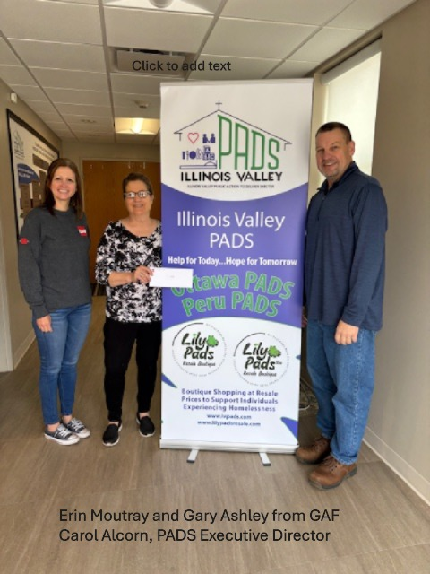
Shop at
Lily PADS Resale Stores
Monday – Saturday
9am -5pm

Your purchases support IV PADS Homeless Shelters

Peru
4473 Progress Blvd.
Ottawa
411 N. 3059th Rd.
---------------------------
Check Out IV PADS New Website
www.ivpads.com
🏠✨ Welcome Home, John and
Ailley Dog! 🐾

Last fall, John came to Ottawa PADS, referred by the Arukah Institute of Healing. From the moment he arrived, his biggest goal was reuniting with his beloved emotional support dog, Ailley Dog, who was being temporarily housed by
Bureau County Animal Control.
Thanks to a community of kindness:
💛 Ottawa Veterinary Hospital donated
boarding
💉 Bureau County Animal Control provided updated vaccinations
📄 Arukah helped secure the proper support animal documentation
While staying with us, John:
✔️ Handled legal matters
✔️ Maintained his health
✔️ Applied for benefits
✔️ Helped others—and even fixed things around the shelter with his toolbox! 🛠️
With help from Tri County Opportunities Council, John got the keys to his own place—and Ailley Dog was right there with him.
🏡 Welcome home, John and Ailley. Your journey inspires us all.
Thank you for trusting IV PADS to walk beside you. 💛

