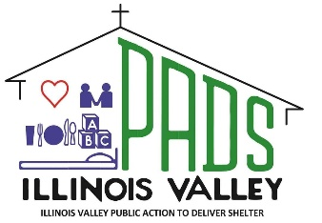
Help for Today…Hope for Tomorrow August 2026
IV PADS P.O. Box 1012 LaSalle, IL 61301
815-224-3047 www.ivpads.com
Homeless Shelters in Peru and Ottawa

Scan to Donate
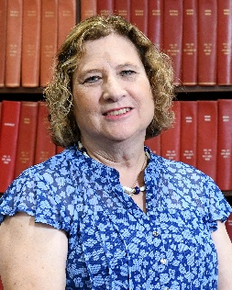
A Message from the Executive Director

As we begin another shelter season on August 1, our Peru PADS Shelter will once again open its doors to provide 24-hour-a-day, 7-day-a-week shelter, meals, and supportive services for individuals and families experiencing homelessness.

This year, however, our ministry begins with a unique challenge. While construction of the new Ottawa PADS Shelter continues to make great progress, the building is not yet ready for occupancy. During this transition period, our Ottawa PADS staff will transport anyone in need of overnight shelter to our Peru PADS Shelter, where they will receive the same compassionate care and support our community has come to expect from IV PADS.

We know this temporary arrangement will require extra time, coordination, and patience from our staff, volunteers, clients, and community partners. It is not the ideal situation, but it is the best way to ensure that no one is left without a safe place to sleep while we prepare for the opening of our new Ottawa facility.

We ask for your understanding, your prayers, and your continued support during this time of transition. Every meal served, every ride provided, every volunteer hour, and every donation helps us continue our mission to the homeless in our communities.

Thank you for standing with IV PADS as we continue this important work together.

Carol Alcorn, IV PADS Executive Director
Happy Easter
Happy Easter

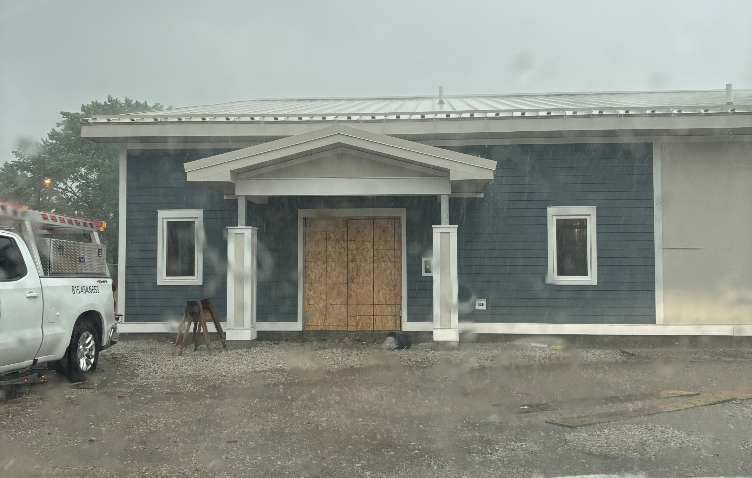
🚚🏠 Getting Ready for a New Chapter at Ottawa PADS Shelter 🏠🚚
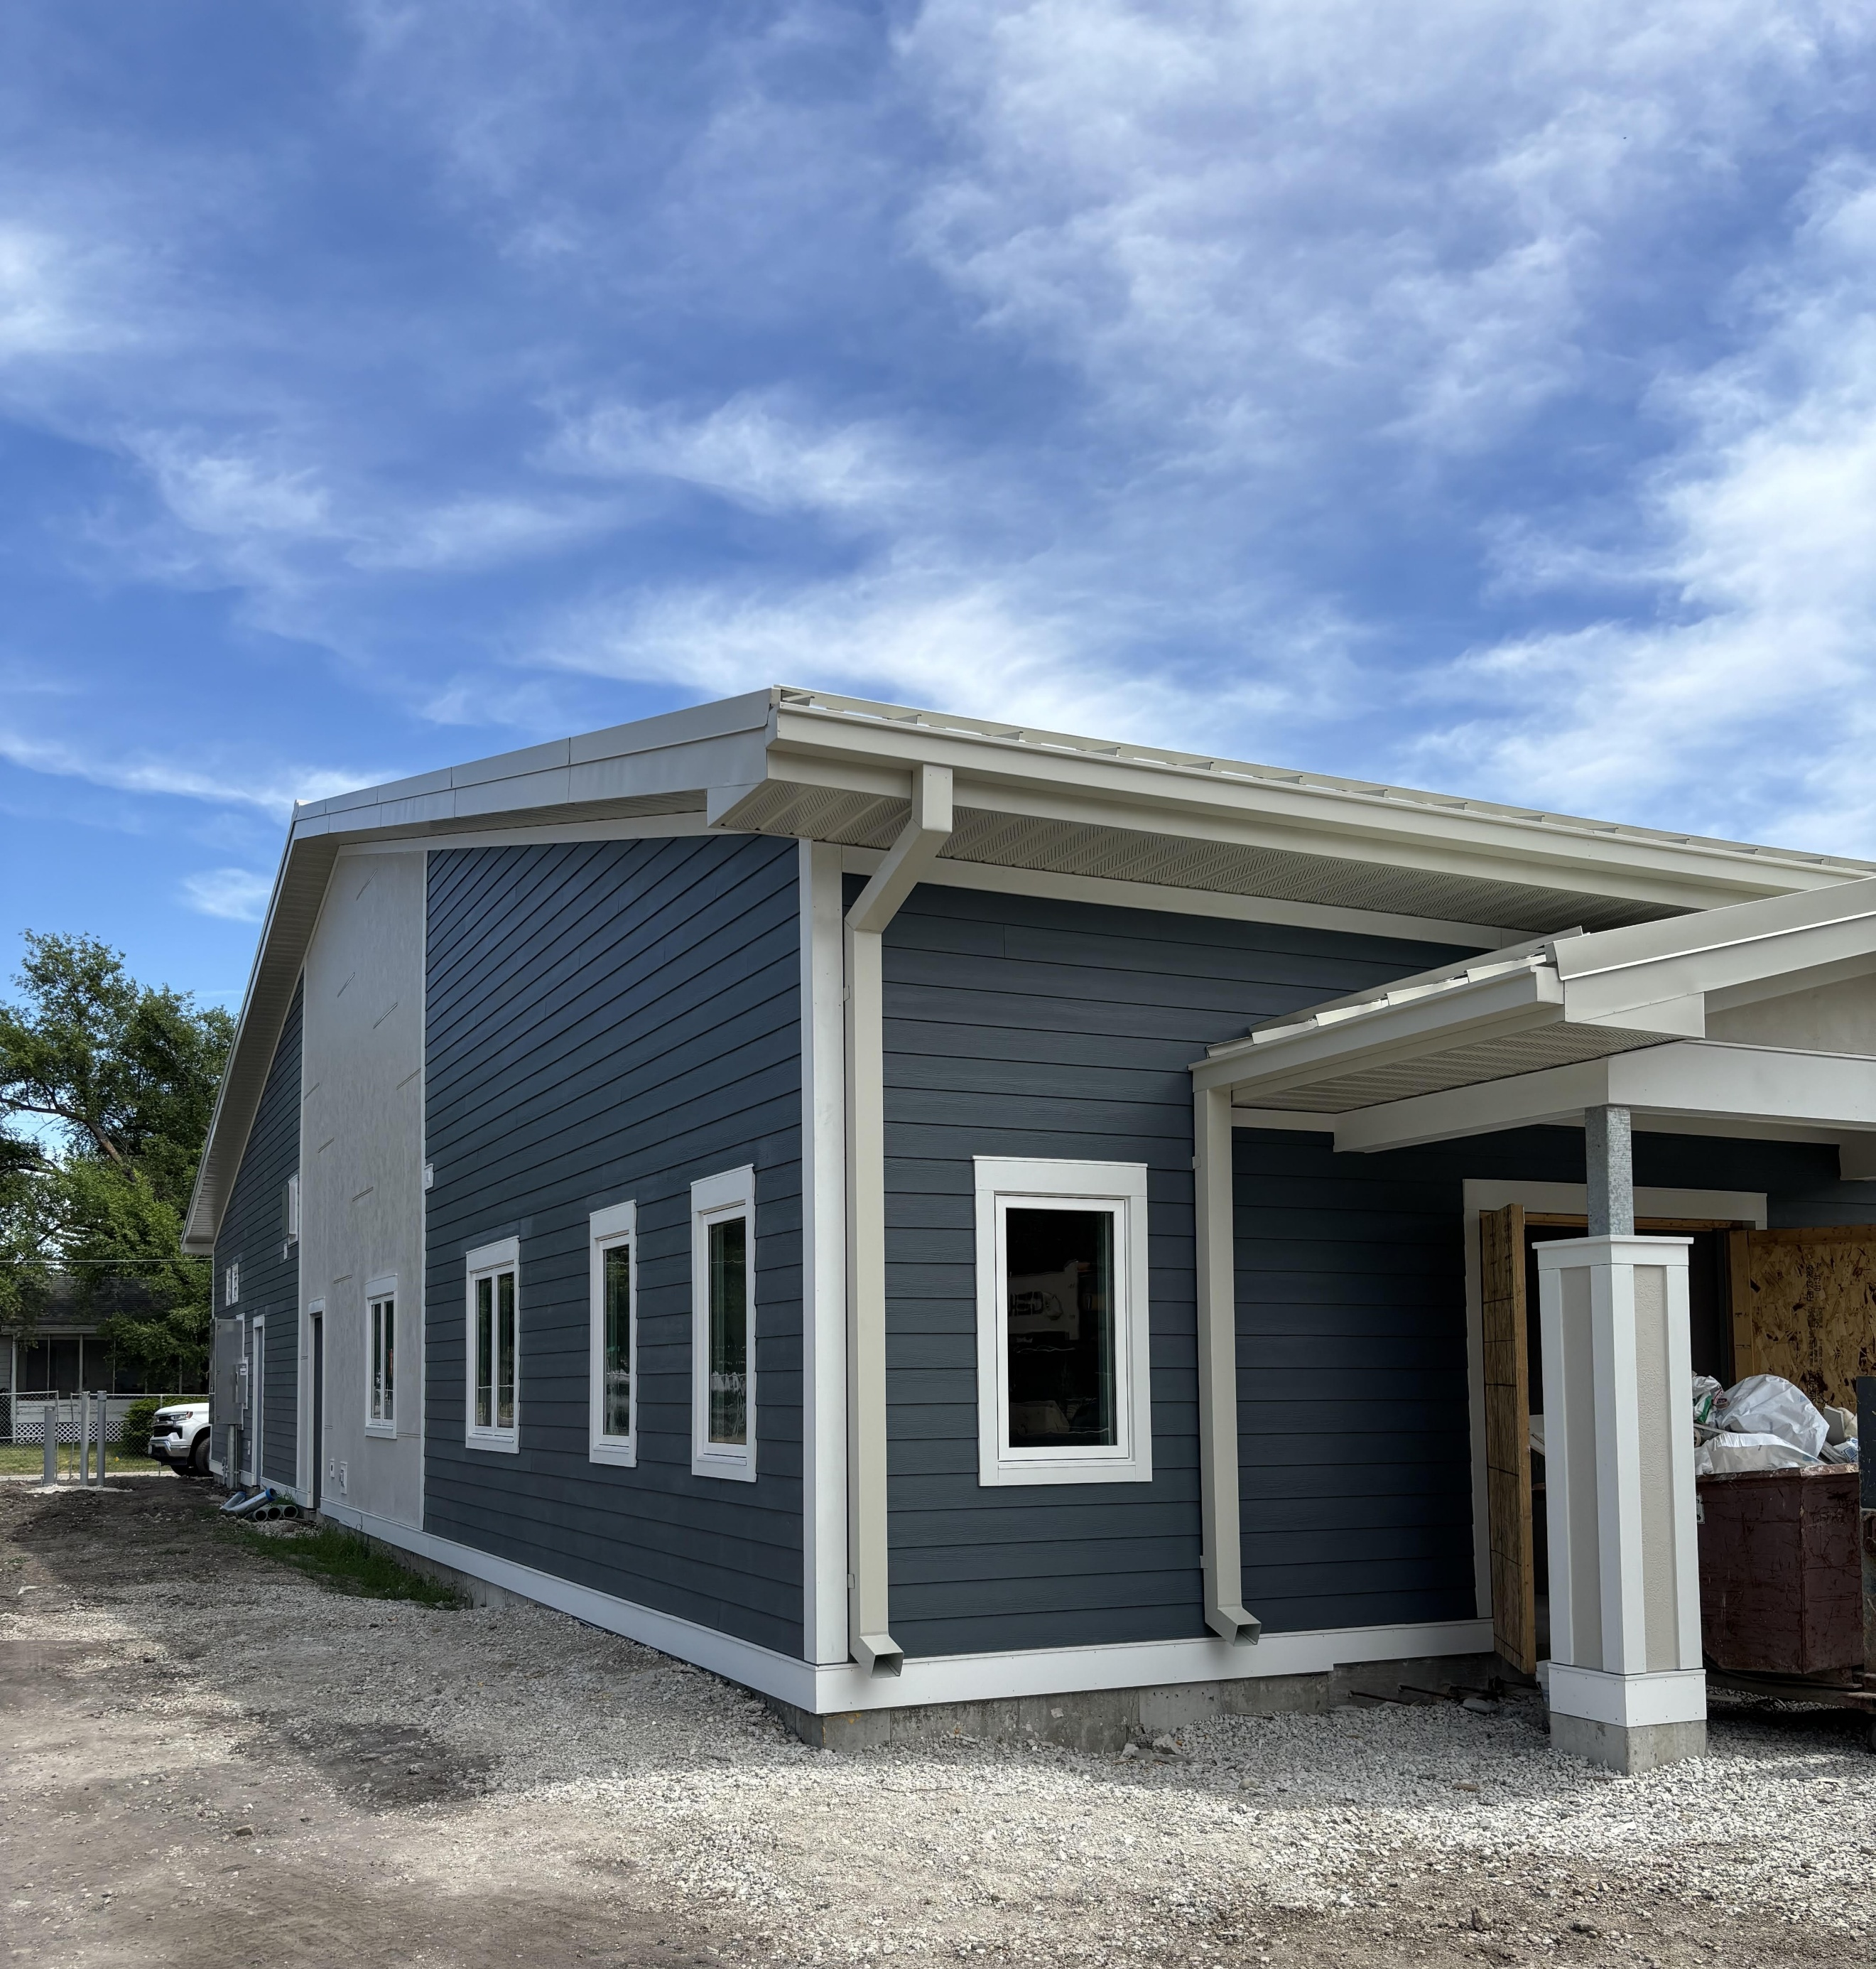
Construction continues to make excellent progress, and we are hopeful that the new shelter will open in early October. This new shelter represents far more than a building—it is an investment in hope for individuals and families experiencing homelessness throughout our community.

We are incredibly grateful to the many donors, businesses, churches, foundations, volunteers, and community partners whose generosity has made this project possible. Your support is helping create a place where lives can be transformed for years to come.

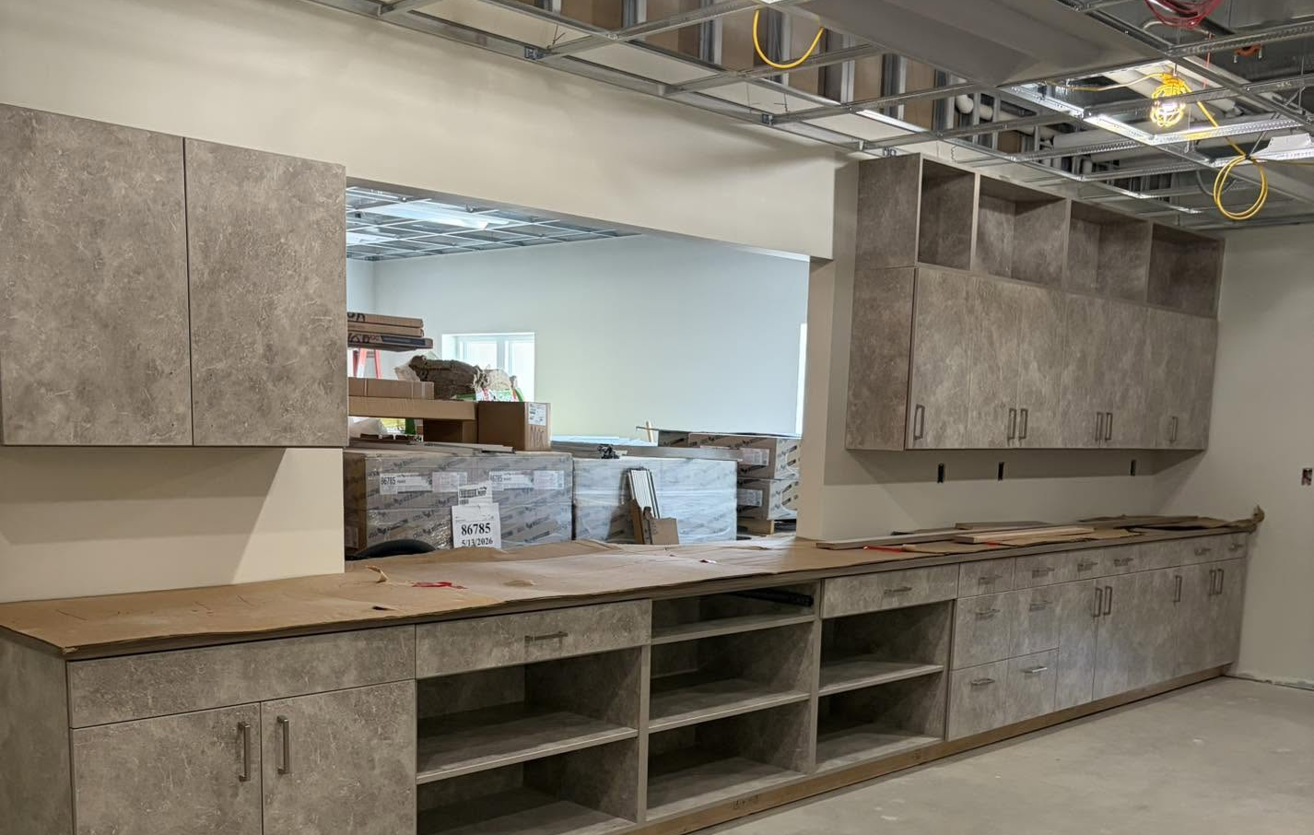

💙 Shop Local.
Donate Local.
Change Lives. 💙

Did you know that
every purchase and
donation at our
Lily PADS Resale
stores helps
support our
homeless shelters in Peru and Ottawa?

Lily PADS in Peru and Lily PADS Too in Ottawa provide vital funding that helps us offer shelter, meals and vital services to individuals and families experiencing homelessness here in the Illinois Valley.

When you donate, your items stay local.
When you shop, your dollars stay local.
Together, you are helping change lives in our community.

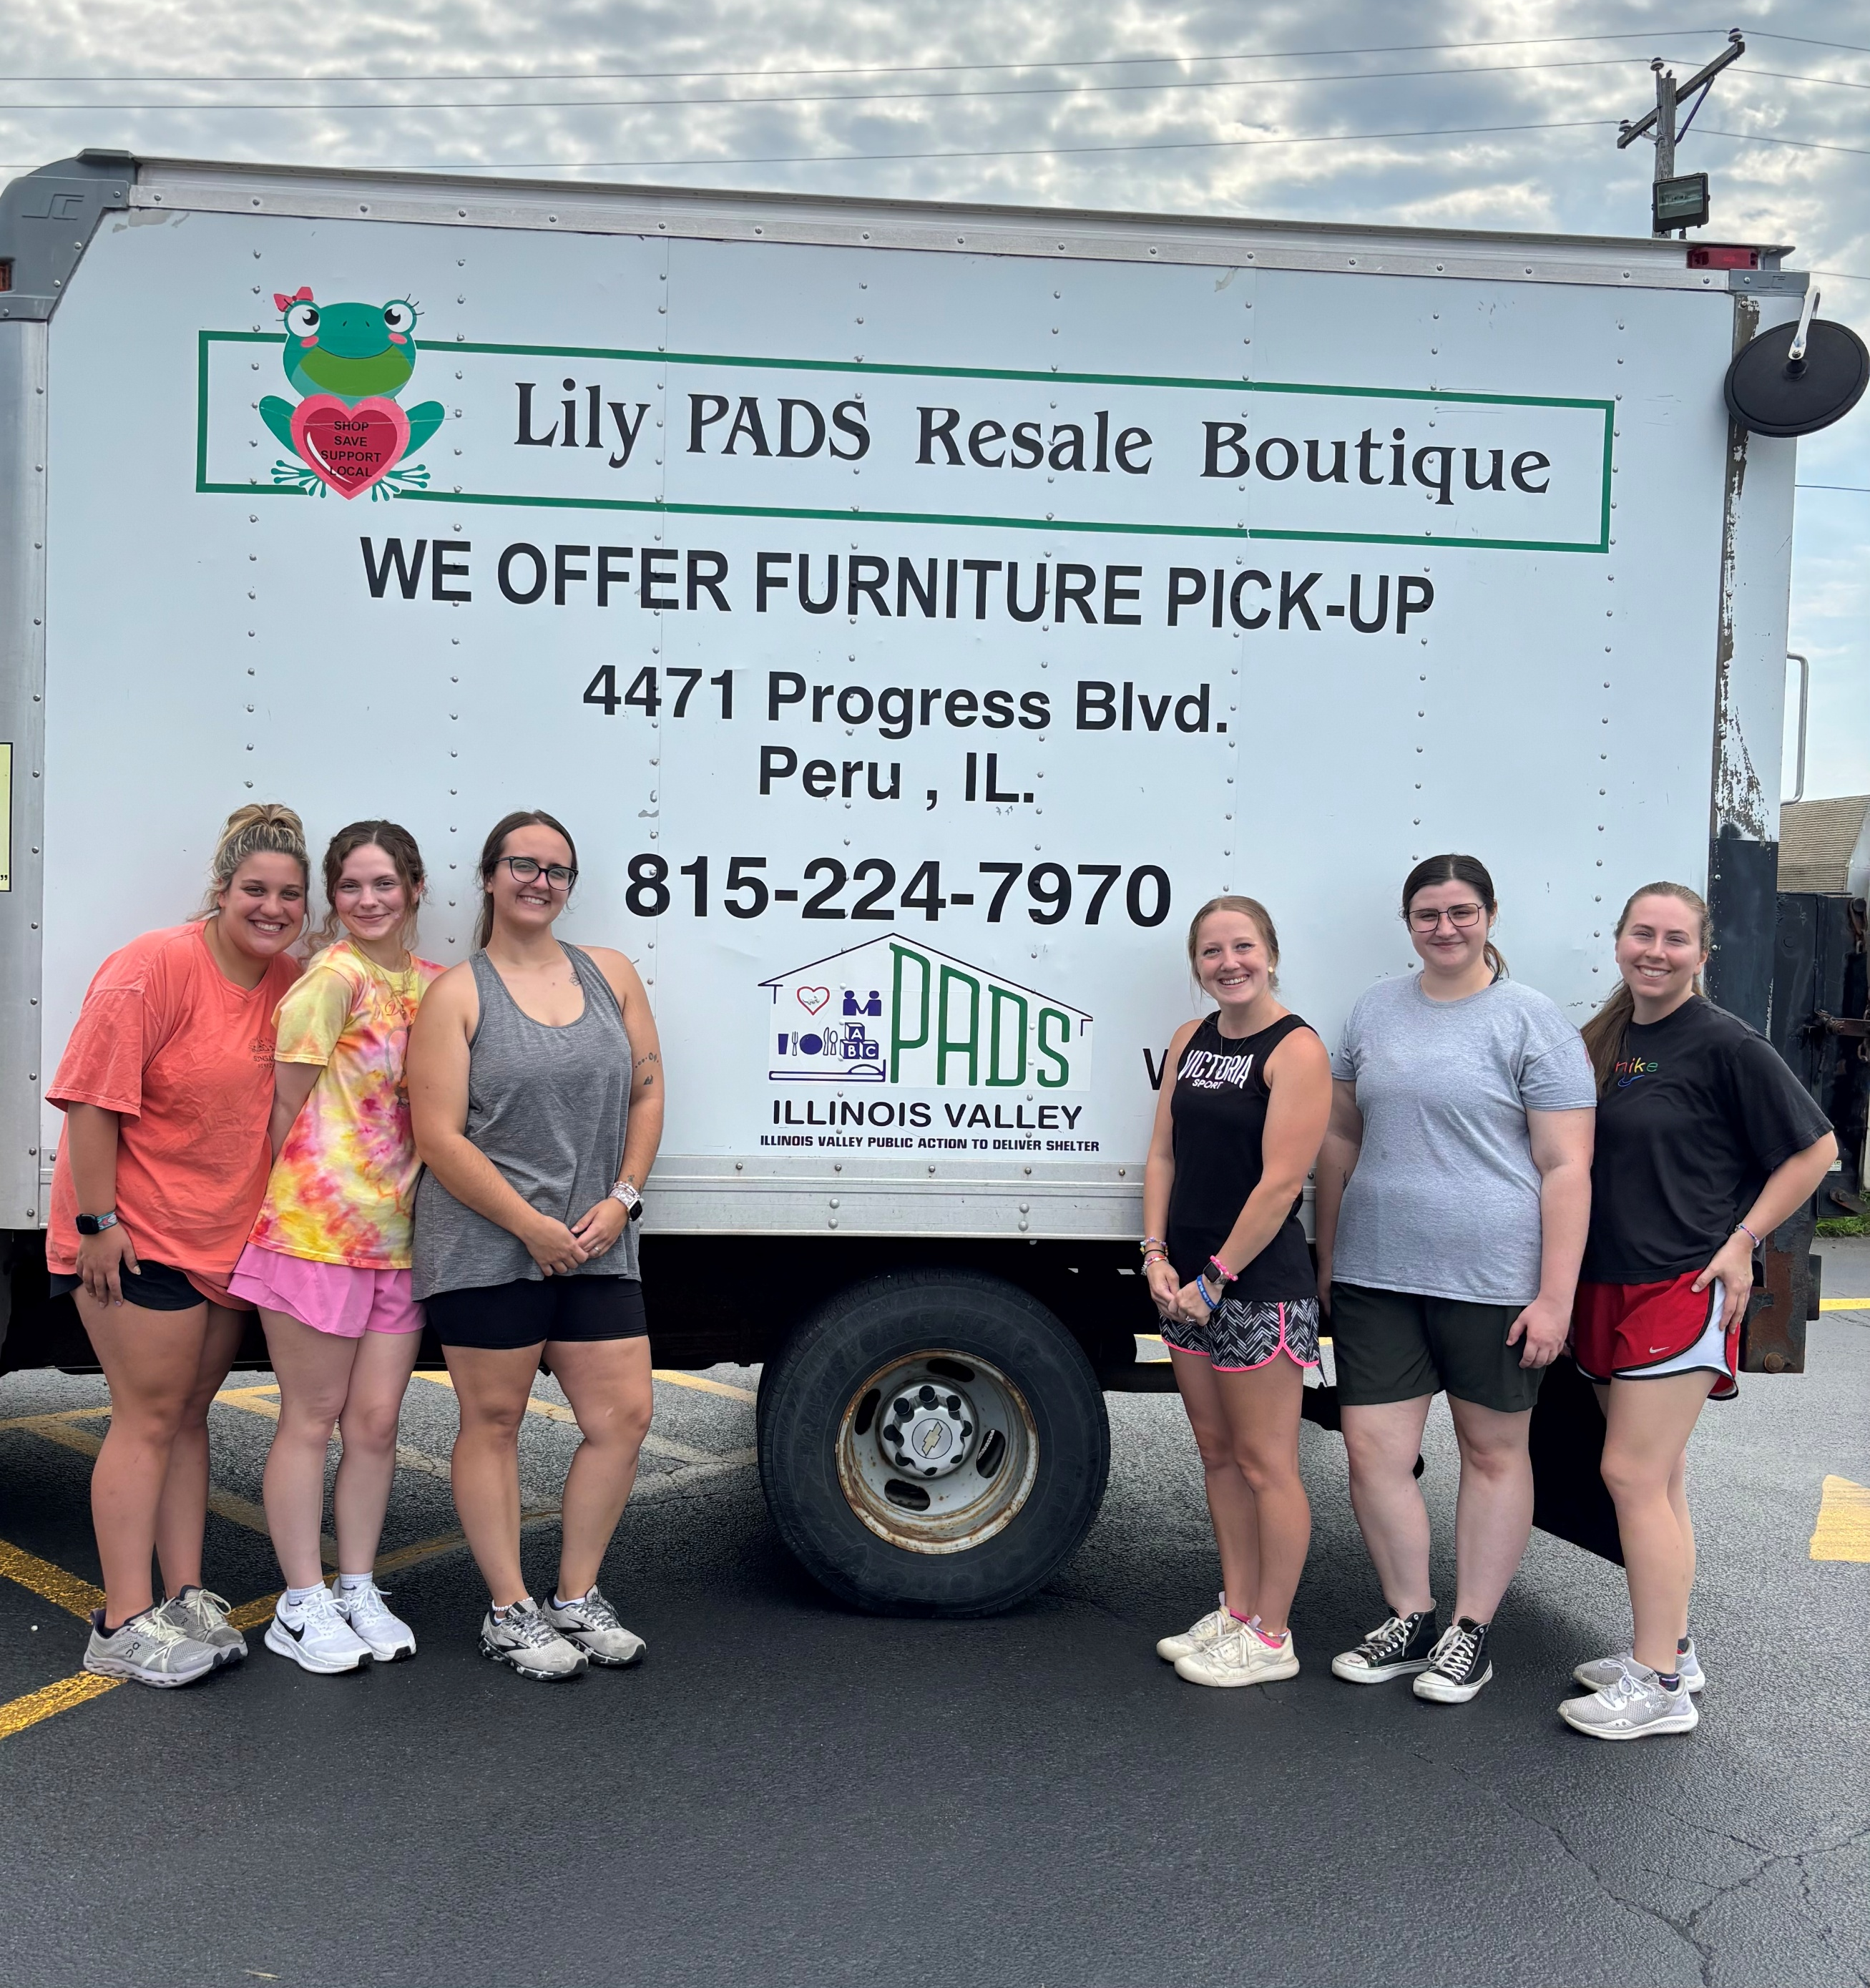
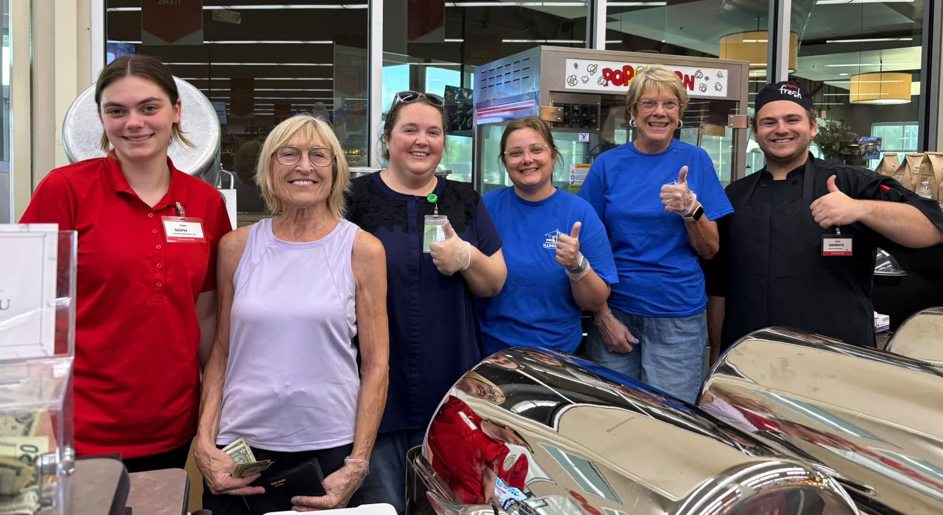
IV PADS extends a heartfelt thank you to Hy-Vee in Peru for selecting us as the featured nonprofit for Steak Night for a Cause on July 2. We are grateful to everyone who stopped by to enjoy a delicious steak dinner while supporting the mission of IV PADS.
Thanks to the amazing support from our community, 142 steak dinners were served—and we sold out!

A special thank you to IV PADS staff Marissa and Brittany, along with Board of Directors Jamie, Joanne, and Sue who helped make the evening a tremendous success while they served the dinners.

Events like Steak Night for a Cause not only raise valuable funds to support our shelters and programs, but they also remind us how fortunate we are to live in a community that cares for its neighbors experiencing homelessness. Thank you, Hy-Vee, and thank you to everyone who purchased a dinner. Your support truly helps provide Help for Today...Hope for Tomorrow.

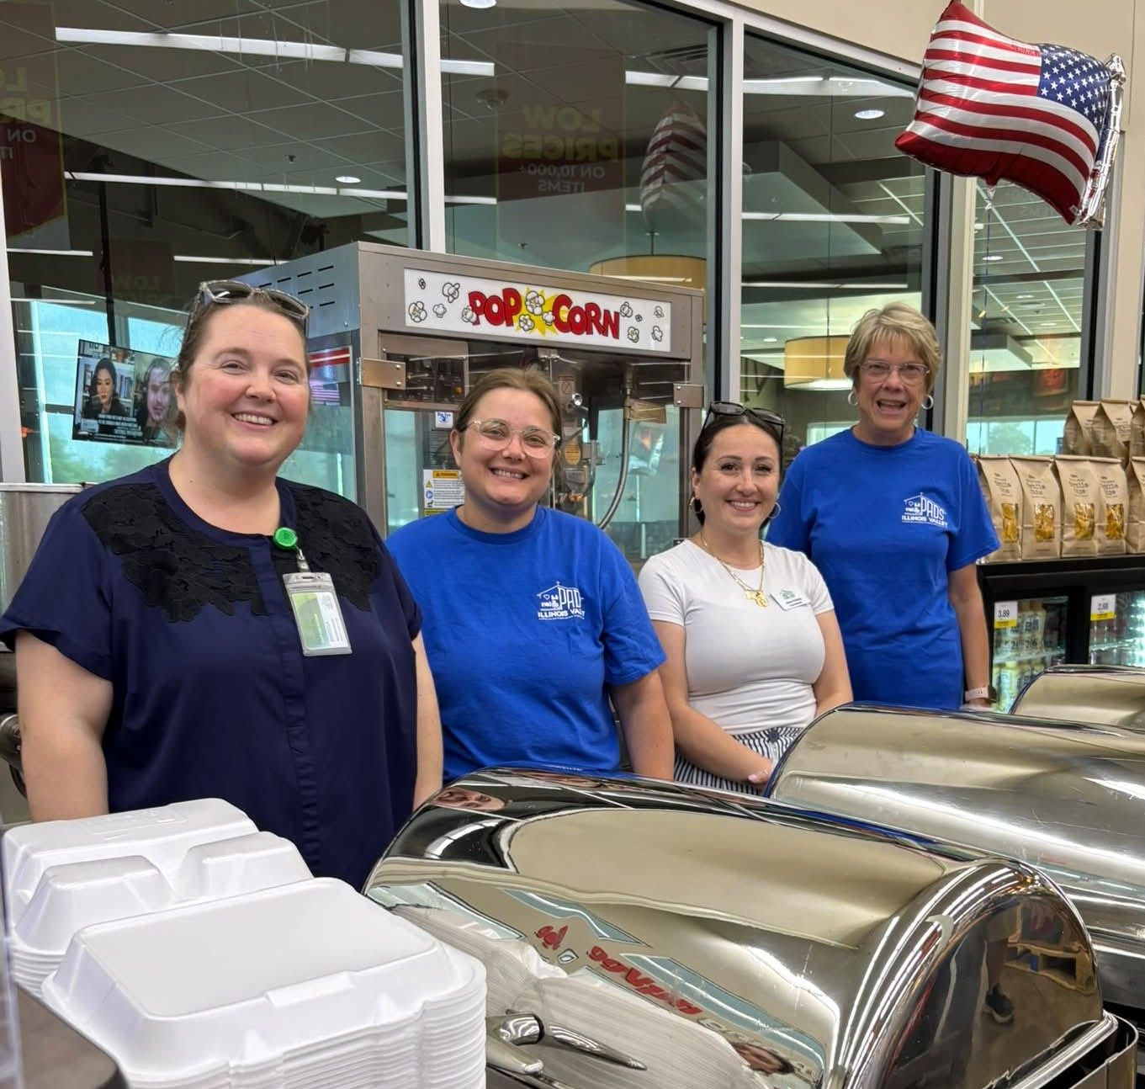

Lily PADS Resale Stores Monday – Saturday 9am -5pm
Peru 4473 Progress Blvd. Ottawa 411 E. Stevenson Rd.

