
IV PADS Homeless Shelters Peru / Ottawa
P.O. Box 1012 LaSalle, IL 61301
815-224-3047 www.ivpads.com

Scan to Donate
Help for Today…Hope for Tomorrow APRIL 2025

Building Hope for a New Shelter in Ottawa

Our journey to build a new shelter facility in Ottawa has been long and full of twists and turns.
Carol Alcorn,
Executive Director

However, thanks to your incredible generosity and the support of so many community members and the City of Ottawa, we are now closer than ever to breaking ground.
Happy Easter
Happy Easter

This new shelter will be fully accessible and able to accommodate up to 100 individuals, providing a safe and supportive environment for those in need. As construction plans move forward, we have identified a potential location for a temporary shelter in Ottawa and are awaiting zoning approval and other transitional arrangements.

We are excited to share that we have received numerous large donations in the past few weeks and are closer to reaching our fundraising goal.

While we celebrate this milestone, there is still work to be done. The need for shelter and support services continues to grow, and with your help, we can cross the finish line

How You Can Help:
Donate: Every contribution moves us closer to our goal.
Volunteer: Your time and skills make a real difference.
Spread the Word: Share our mission with your network to build community support

Together, we are building a future where everyone has a place to call home. Let’s keep up the momentum!

A Veteran’s Story

A New Home

Recently, I was blessed to witness a significant milestone in a client’s life, a veteran who has undoubtedly faced many challenges.

We drove to look at a studio and it was a perfect fit! I took him to meet the housing manager and what felt like an eternity later, he walked out with a packet – his lease!

He was smiling from ear to ear, and he got in the car jingling his new keys. Being a veteran myself, my emotions got the best of me. May God bless him on his new journey. 🙏.

Brenda Salas, Peru Program Director

Facebook Illinois Valley PADS
Lily PADS Peru
4473 Progress Blvd.
Peru, IL 61354
815-224-4970

Lily PADS Too Ottawa
411 N. 3059th Rd.
Ottawa, IL 61350
815-313-5776
Shop at Lily PADS Resale Stores in Peru & Ottawa!
🛍️ Store Hours:
Monday – Saturday | 9 AM – 5 PM
📦 Donations of Furniture Needed Now!
Thank you for supporting IV PADS Homeless Shelters through Lily PADS!

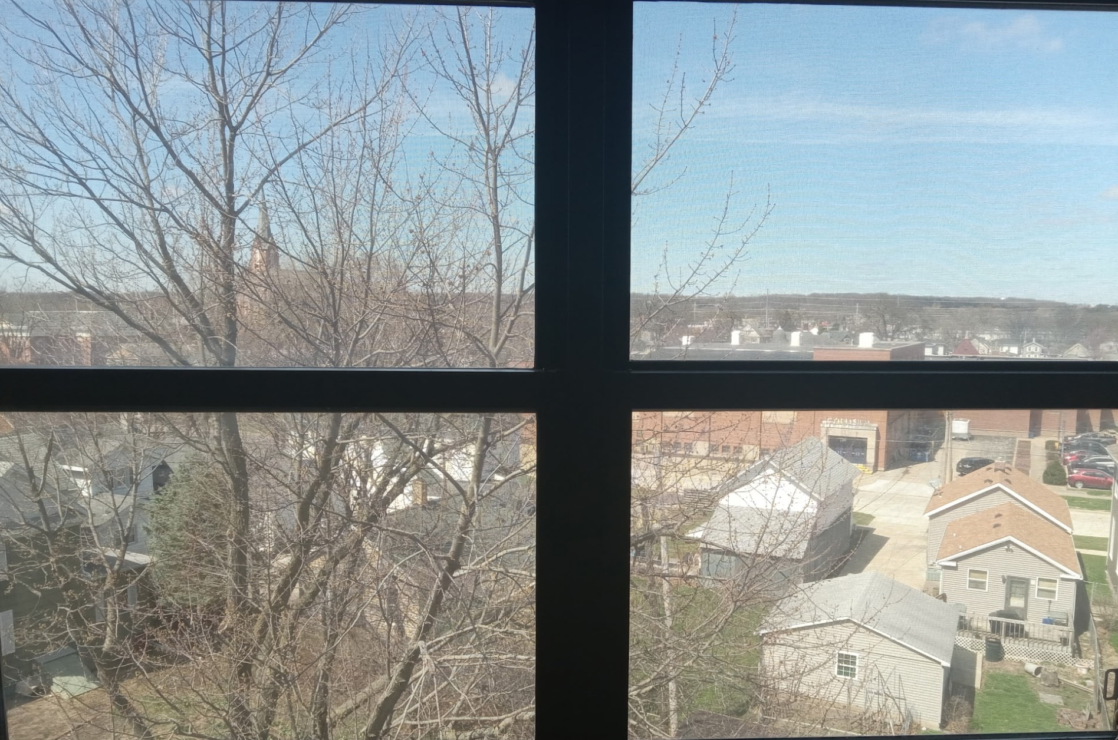
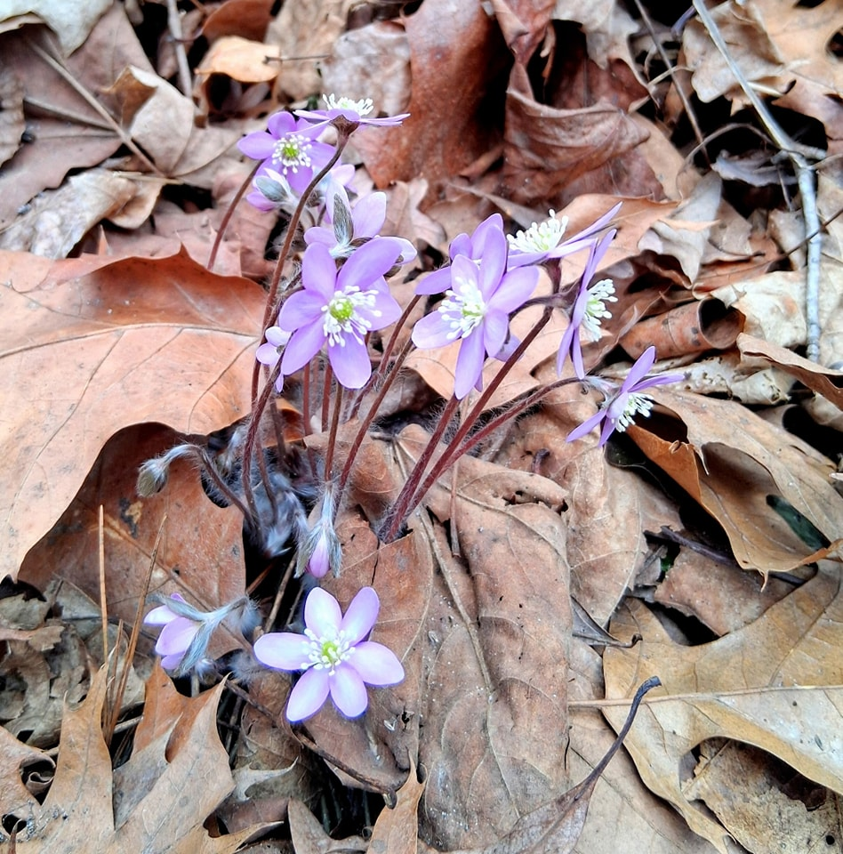
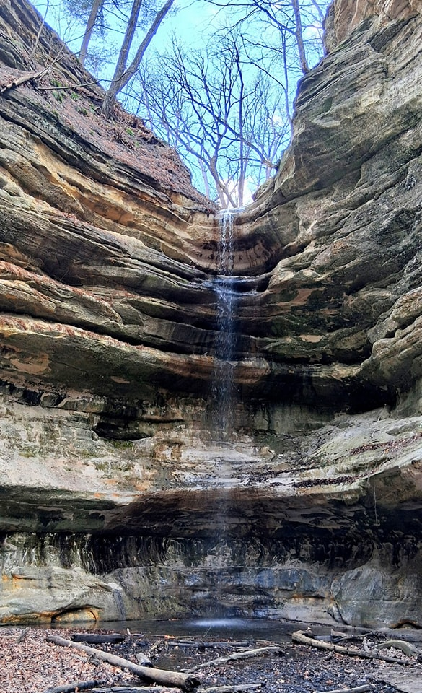

A PADS Outing
Our staff member Amber is always looking for healthy, fun activities for our clients to incorporate into their lives. Recently she took them to explore nature and breathe.
"Nature is the greatest place to heal and recharge" - John McGrath.
